Name: K Subrahmanyam
Reg no. 192312521
ITA0602 – MACHINE LEARNING
CO1 AT1 – Application Based Question

Question 11
Definition
Bayes' Theorem is one of the most important concepts in probability theory and machine learning. It is used to calculate the probability of an event based on prior knowledge of conditions related to that event. In simple terms, Bayes' Theorem helps us update our beliefs when new information becomes available.
In machine learning, Bayes' Theorem is widely used in classification algorithms such as the Naïve Bayes Classifier, spam email detection, medical diagnosis, fraud detection, and recommendation systems.
The theorem provides a mathematical way to revise an existing probability after observing new evidence.
Theory
Bayes' Theorem relates conditional probability with prior probability and likelihood.
The mathematical formula is
$$P(A∣B)=\frac{P(B∣A)×P(A)}{P(B)}$$
where:
- P(A|B) = Posterior Probability (Probability of event A after observing event B)
- P(B|A) = Likelihood (Probability of observing B if A has occurred)
- P(A) = Prior Probability (Initial probability of A)
- P(B) = Total probability of observing B
The theorem is useful whenever we know the probability of observing an event but want to determine the probability of its cause.
Application of Bayes' Theorem in Machine Learning
Bayes' Theorem is used in many real-world machine learning applications, including:
- Email spam filtering
- Disease diagnosis
- Weather forecasting
- Credit card fraud detection
- Customer behavior prediction
- Image recognition
- Recommendation systems
In this problem, the theorem helps determine from which shop an adulterated bottle most likely originated.
Given Data
Shop X
- Pure Oil Bottles = 20
- Adulterated Oil Bottles = 30
- Total Bottles = 50
Shop Y
- Pure Oil Bottles = 40
- Adulterated Oil Bottles = 20
- Total Bottles = 60
Probability of selecting Shop Y is twice that of Shop X.
Therefore,
Let
$$P(X)=x$$
Then
$$P(Y)=2x$$
Since
$$P(X)+P(Y)=1 \\ x+2x=1 \\ 3x=1 \\ P(X)=\frac{1}{3}$$
and
$$P(Y)=\frac{2}{3}$$
Step 1: Calculate the Probability of Selecting an Adulterated Bottle
For Shop X
$$P(A∣X)=\frac{30}{50}=0.6$$
For Shop Y
$$P(A∣Y)=\frac{20}{60}=\frac{1}{3}=0.3333$$
Step 2: Calculate Total Probability of Selecting an Adulterated Bottle
Using the Law of Total Probability,
$$P(A)=P(A∣X)P(X)+P(A∣Y)P(Y)$$
Substituting the values,
$$P(A)=0.6\left(\frac{1}{3}\right)+0.3333\left(\frac{2}{3}\right) \\ P(A)=0.2+0.2222 \\ P(A)=0.4222$$
Using fractions,
$$P(A)=\frac{19}{45}$$
Step 3: Apply Bayes' Theorem
We need
$$P(X∣A)$$
Applying Bayes' theorem,
$$P(X∣A)=\frac{P(A∣X)P(X)}{P(A)}$$
Substituting the values,
$$P(X∣A)=\frac{0.6×\frac{1}{3}}{\frac{19}{45}} \\ =\frac{\frac{1}{5}}{\frac{19}{45}} \\ =\frac{9}{19}$$
Therefore,
$$P(X∣A)=0.4737$$
or
$$\boxed{47.37\%}$$
Final Answer
The probability that the adulterated bottle came from Shop X is
$$\boxed{\frac{9}{19}=0.4737=47.37\%}$$
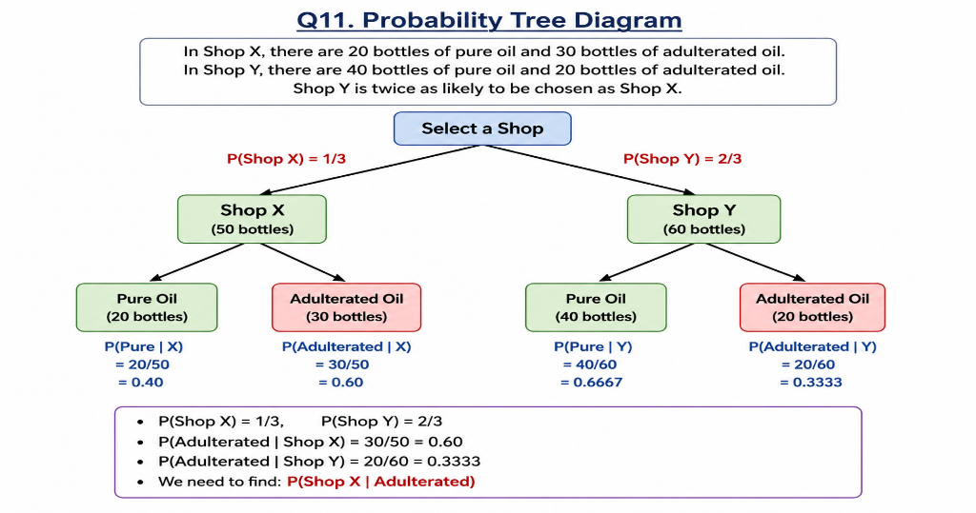
Interpretation
The result shows that even though Shop Y is selected twice as often as Shop X, the probability that an adulterated bottle came from Shop X is still 47.37%.
This is because Shop X has a much higher proportion of adulterated bottles (60%) compared to Shop Y (33.33%).
Bayes' Theorem combines both the prior probability of choosing each shop and the probability of selecting an adulterated bottle from that shop. The final probability reflects the combined effect of these two factors.
Real-Life Example
A similar situation occurs in hospitals. Suppose two hospitals perform COVID-19 testing. One hospital conducts more tests than the other, but the second hospital has a much higher infection rate among its patients. If a patient tests positive, Bayes' Theorem can determine which hospital the patient is more likely to have visited.
Likewise, insurance companies use Bayes' Theorem to estimate the likelihood of fraud based on previous claim histories.
Reasoning
Bayes' Theorem is preferred because it considers both:
- The probability of selecting a particular shop.
- The probability of obtaining an adulterated bottle from that shop.
Simply comparing the number of adulterated bottles is not sufficient because the shops are not equally likely to be selected. The theorem provides a mathematically correct method for combining prior information with observed evidence.
Critique (Limitations)
Although Bayes' Theorem is powerful, it has some limitations:
- It depends on accurate prior probabilities.
- Incorrect or biased prior information can produce misleading results.
- It assumes that the available probabilities are reliable and complete.
- In complex machine learning problems, estimating prior probabilities can be difficult.
- For very large datasets, Bayesian calculations may become computationally intensive.
Despite these limitations, Bayes' Theorem remains one of the most widely used probability techniques in statistics, artificial intelligence, and machine learning.
Conclusion
This problem demonstrated the application of Bayes' Theorem to determine the probability that an adulterated oil bottle originated from Shop X. By combining the probability of selecting each shop with the probability of finding an adulterated bottle in each shop, the posterior probability was calculated successfully. The final probability obtained was 47.37%, showing how Bayesian reasoning updates probabilities when new evidence becomes available. Bayes' Theorem plays a crucial role in machine learning algorithms such as Naïve Bayes and is extensively used in medical diagnosis, fraud detection, and decision-making systems.
Question 12
Definition
Bayes' Theorem is a statistical method used to determine the probability of an event after considering new evidence. It combines prior knowledge with observed data to calculate a revised probability. Bayes' Theorem is one of the most important concepts in probability theory and plays a significant role in machine learning, artificial intelligence, statistics, and decision-making.
In machine learning, Bayes' Theorem is the foundation of the Naïve Bayes Classifier, which is widely used for spam filtering, document classification, medical diagnosis, fraud detection, and recommendation systems.
The theorem allows us to update our belief about an event whenever additional information becomes available.
Theory
Bayes' Theorem is expressed mathematically as
$$P(A∣B)=\frac{P(B∣A)×P(A)}{P(B)}$$
where:
- P(A|B) = Posterior Probability (Probability that the item came from Section A after observing that it is defective)
- P(B|A) = Likelihood (Probability of selecting a defective item from Section A)
- P(A) = Prior Probability of selecting Section A
- P(B) = Total Probability of selecting a defective item
The theorem combines prior probabilities with observed evidence to calculate the required conditional probability.
Applications of Bayes' Theorem
Bayes' Theorem is widely used in many fields, including:
- Medical diagnosis
- Machine learning classification
- Email spam filtering
- Credit card fraud detection
- Quality control in manufacturing
- Weather forecasting
- Predictive analytics
- Artificial Intelligence
In this problem, Bayes' Theorem helps identify from which warehouse section the defective item most likely originated.
Given Data
Section A
- Defective Items = 15
- Non-Defective Items = 35
- Total Items = 50
Section B
- Defective Items = 25
- Non-Defective Items = 25
- Total Items = 50
Section A is three times as likely to be selected as Section B.
Step 1: Calculate Prior Probabilities
Let
$$P(B)=x$$
Since Section A is three times more likely,
$$P(A)=3x$$
Since
$$P(A)+P(B)=1 \\ 3x+x=1 \\ 4x=1 \\ x=\frac{1}{4}$$
Therefore,
$$P(A)=\frac{3}{4}$$
and
$$P(B)=\frac{1}{4}$$
Step 2: Calculate the Probability of Selecting a Defective Item
For Section A,
$$P(D∣A)=\frac{15}{50}=0.30$$
For Section B,
$$P(D∣B)=\frac{25}{50}=0.50$$
Step 3: Calculate Total Probability of Selecting a Defective Item
Using the Law of Total Probability,
$$P(D)=P(D∣A)×P(A)+P(D∣B)×P(B)$$
Substituting the values,
$$P(D)=0.30×\frac{3}{4}+0.50×\frac{1}{4} \\ P(D)=0.225+0.125 \\ P(D)=0.35$$
Step 4: Apply Bayes' Theorem
We need to find
$$P(A∣D)$$
Applying Bayes' Theorem,
$$P(A∣D)=\frac{P(D∣A)×P(A)}{P(D)}$$
Substituting the values,
$$P(A∣D)=\frac{0.30×\frac{3}{4}}{0.35} \\ =\frac{0.225}{0.35} \\ =0.642857$$
or
$$=\frac{9}{14}$$
Final Answer
Therefore,
$$\boxed{P(\text{Section A | Defective})=\frac{9}{14}=0.6429}$$
Hence, the probability that the defective item came from Section A is
$$\boxed{64.29\%}$$
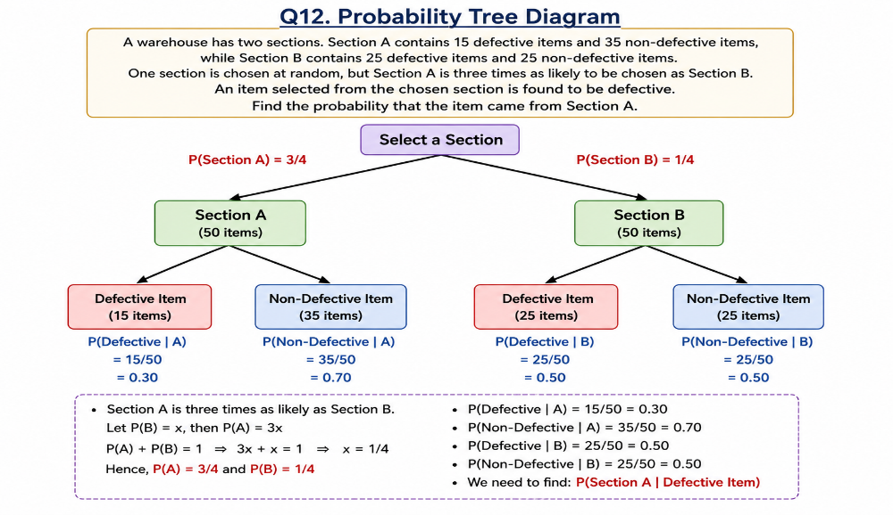
Interpretation
The result shows that after observing a defective item, there is a 64.29% probability that it originated from Section A.
Although Section B has a higher defect rate (50%) compared to Section A (30%), Section A is selected much more frequently because it is three times more likely to be chosen. This higher prior probability increases the likelihood that the defective item came from Section A.
Bayes' Theorem combines both the selection probability and the defect rate to provide the correct posterior probability.
Real-Life Example
A manufacturing company may have two production units producing the same product. Suppose Unit A manufactures three times as many products as Unit B, but Unit B has a higher defect rate.
If a defective product is found during inspection, Bayes' Theorem can determine the probability that the product was manufactured by Unit A or Unit B. This helps engineers identify which production line requires quality improvement.
Similarly, hospitals use Bayes' Theorem to determine the probability of a disease after receiving a positive test result, taking into account both the prevalence of the disease and the accuracy of the test.
Reasoning
Bayes' Theorem is appropriate because it combines:
- Prior Probability – the probability of selecting each warehouse section.
- Likelihood – the probability of selecting a defective item from each section.
- Observed Evidence – the selected item is defective.
Without Bayes' Theorem, simply comparing defect percentages would lead to an incorrect conclusion because it ignores the fact that Section A is selected much more frequently.
Critique (Limitations)
Although Bayes' Theorem is highly effective, it has certain limitations:
- It depends on accurate prior probabilities.
- Incorrect prior information may lead to misleading results.
- The method assumes that all probabilities are known accurately.
- Real-world datasets may contain uncertainties and incomplete information.
- In machine learning, Naïve Bayes assumes feature independence, which may not always hold true.
Despite these limitations, Bayes' Theorem remains one of the most reliable techniques for probabilistic reasoning and decision-making.

Conclusion
This problem demonstrated the application of Bayes' Theorem to determine the probability that a defective item originated from Section A. By considering both the probability of selecting each warehouse section and the probability of finding a defective item within that section, the posterior probability was calculated successfully. The final probability obtained was 64.29%, indicating that the defective item is more likely to have come from Section A. Bayes' Theorem is widely used in machine learning, quality control, medical diagnosis, and artificial intelligence for making informed decisions based on available evidence.

Question 13
Definition
In Machine Learning, a classification model predicts the category or class of a given input. After training a model, its performance must be evaluated to determine how accurately it classifies new data. This evaluation is performed using several performance metrics derived from a Confusion Matrix.
A Confusion Matrix is a table that summarizes the prediction results of a classification model by comparing the actual class labels with the predicted class labels.
Performance metrics such as Accuracy, Precision, Sensitivity (Recall), and Specificity are calculated using the values from the confusion matrix.
These metrics help determine whether the model is suitable for real-world applications like disease diagnosis, spam detection, fraud detection, and image classification.
Theory
A binary classification model predicts one of two possible classes:
- Positive Class
- Negative Class
The confusion matrix contains four possible outcomes.
Actual Class | Predicted Positive | Predicted Negative
Positive | True Positive (TP) | False Negative (FN)
Negative | False Positive (FP) | True Negative (TN)
Given Data
True Positive (TP) = 120
True Negative (TN) = 150
Samples in Positive Class = 1000
Samples in Negative Class = 1000
Testing Data = 20%
Step 1: Calculate Total Test Samples
Total dataset
$$1000+1000=2000$$
Testing data
$$20\%×2000 \\ =\frac{20}{100}×2000 \\ =400$$
Therefore,
Total Test Samples = 400
Since there are equal samples in both classes,
Positive Test Samples
$$1000×20\%=200$$
Negative Test Samples
$$1000×20\%=200$$
Step 2: Calculate False Negative (FN)
Positive Test Samples
$$200$$
True Positive
$$120$$
Therefore,
$$FN=200-120 \\ FN=80$$
Step 3: Calculate False Positive (FP)
Negative Test Samples
$$200$$
True Negative
$$150$$
Therefore,
$$FP=200-150 \\ FP=50$$
Step 4: Construct the Confusion Matrix
Actual Class | Predicted Positive | Predicted Negative
Positive | TP = 120 | FN = 80
Negative | FP = 50 | TN = 150
(Insert the Confusion Matrix image here.)
Step 5: Calculate Accuracy
Formula
$$Accuracy=\frac{TP+TN}{TP+TN+FP+FN}$$
Substitute the values
$$=\frac{120+150}{120+150+50+80} \\ =\frac{270}{400} \\ =0.675$$
Accuracy
$$\boxed{67.5\%}$$
Step 6: Calculate Precision
Formula
$$Precision=\frac{TP}{TP+FP}$$
Substitute
$$=\frac{120}{120+50} \\ =\frac{120}{170} \\ =0.7059$$
Precision
$$\boxed{70.59\%}$$
Step 7: Calculate Sensitivity (Recall)
Formula
$$Sensitivity=\frac{TP}{TP+FN}$$
Substitute
$$=\frac{120}{120+80} \\ =\frac{120}{200} \\ =0.60$$
Sensitivity
$$\boxed{60\%}$$
Step 8: Calculate Specificity
Formula
$$Specificity=\frac{TN}{TN+FP}$$
Substitute
$$=\frac{150}{150+50} \\ =\frac{150}{200} \\ =0.75$$
Specificity
$$\boxed{75\%}$$
Final Answers
Performance Metric | Value
Accuracy | 67.5%
Precision | 70.59%
Sensitivity (Recall) | 60%
Specificity | 75%

Interpretation
The classification model achieved an accuracy of 67.5%, meaning it correctly classified approximately two-thirds of the test samples. This indicates moderate overall performance, but there is room for improvement.
The precision of 70.59% shows that when the model predicts a positive class, it is correct about 71% of the time. This means the model has a relatively low number of false positive predictions.
The sensitivity (recall) of 60% indicates that the model correctly identified only 60% of the actual positive samples. A recall of 60% suggests that many positive cases were missed, resulting in a significant number of false negatives.
The specificity of 75% means the model correctly identified 75% of the actual negative samples. This indicates that the classifier performs better at identifying negative samples than positive ones.
Overall, the model has better specificity than sensitivity, making it more effective at recognizing negative cases than positive cases.
Real-Life Example
Consider a medical diagnostic system used to detect a disease. If the recall is low, many patients who actually have the disease may be classified as healthy. This can have serious consequences because treatment may be delayed.
Similarly, in fraud detection systems, a low recall means fraudulent transactions may go undetected. Therefore, selecting appropriate evaluation metrics is crucial depending on the application.
Reasoning
Each performance metric measures a different aspect of model performance:
- Accuracy measures overall correctness.
- Precision measures the reliability of positive predictions.
- Sensitivity (Recall) measures the ability to detect positive cases.
- Specificity measures the ability to correctly identify negative cases.
Using only accuracy may be misleading, especially when datasets are imbalanced. Therefore, all four metrics should be considered together for a complete evaluation.
Critique (Limitations)
Although these metrics provide valuable insights, they have some limitations:
- Accuracy may be misleading for imbalanced datasets.
- Precision does not indicate how many positive samples were missed.
- Recall ignores false positive predictions.
- Specificity focuses only on negative samples.
- A single metric cannot completely describe the performance of a machine learning model.
For this reason, machine learning researchers often use additional metrics such as F1-score, ROC Curve, and AUC for a more comprehensive evaluation.
Conclusion
In this experiment, the performance of a binary classification model was evaluated using a confusion matrix. The calculated results were Accuracy = 67.5%, Precision = 70.59%, Sensitivity = 60%, and Specificity = 75%. These metrics indicate that the model performs reasonably well but has a lower ability to detect positive cases compared to negative cases. Evaluating multiple performance metrics provides a better understanding of the strengths and weaknesses of a classification model, making it easier to improve its predictive performance in real-world machine learning applications.

Question 14
Definition
Medical image classification is an important application of Machine Learning (ML) and Deep Learning (DL). It is used to automatically identify diseases from medical images such as X-rays, CT scans, MRI scans, and ultrasound images. After training a classification model, it is essential to evaluate its performance to ensure that it provides reliable predictions.
The performance of a classification model is measured using a Confusion Matrix, which summarizes the predicted and actual classifications. From the confusion matrix, several evaluation metrics such as Accuracy, Precision, Sensitivity (Recall), and Specificity are calculated.
These metrics help researchers and medical professionals understand how effectively the model identifies diseased and healthy patients.
Theory
A binary classification model predicts one of two classes:
- Positive (Disease Present)
- Negative (Disease Absent)
The prediction results are summarized in a Confusion Matrix.
Actual Class | Predicted Positive | Predicted Negative
Positive | True Positive (TP) | False Negative (FN)
Negative | False Positive (FP) | True Negative (TN)
Meaning of Each Term
True Positive (TP)
The model correctly identifies a patient who has the disease.
True Negative (TN)
The model correctly identifies a healthy patient.
False Positive (FP)
The model incorrectly predicts that a healthy patient has the disease.
False Negative (FN)
The model incorrectly predicts that a diseased patient is healthy.
In medical diagnosis, False Negatives are particularly dangerous because they may result in delayed treatment.
Applications
Performance metrics are widely used in:
- Medical image diagnosis
- Cancer detection
- COVID-19 prediction
- Brain tumor detection
- Face recognition
- Email spam filtering
- Credit card fraud detection
- Object recognition
- Artificial Intelligence systems
Given Data
True Positive (TP) = 180
True Negative (TN) = 160
Samples per Class = 1200
Testing Data = 25%
Step 1: Calculate Total Test Samples
Total Dataset
$$1200+1200=2400$$
Testing Data
$$25\%×2400 \\ =\frac{25}{100}×2400 \\ =600$$
Therefore,
Total Test Samples = 600
Since both classes have equal samples,
Positive Test Samples
$$1200×25\%=300$$
Negative Test Samples
$$1200×25\%=300$$
Step 2: Calculate False Negative (FN)
Positive Test Samples
$$300$$
True Positive
$$180$$
Therefore,
$$FN=300-180 \\ FN=120$$
Step 3: Calculate False Positive (FP)
Negative Test Samples
$$300$$
True Negative
$$160$$
Therefore,
$$FP=300-160 \\ FP=140$$
Step 4: Construct the Confusion Matrix
Actual Class | Predicted Positive | Predicted Negative
Positive | TP = 180 | FN = 120
Negative | FP = 140 | TN = 160

Step 5: Calculate Accuracy
Formula
$$Accuracy=\frac{TP+TN}{TP+TN+FP+FN}$$
Substitute the values
$$=\frac{180+160}{180+160+140+120} \\ =\frac{340}{600} \\ =0.5667$$
Accuracy
$$\boxed{56.67\%}$$
Step 6: Calculate Precision
Formula
$$Precision=\frac{TP}{TP+FP}$$
Substitute
$$=\frac{180}{180+140} \\ =\frac{180}{320} \\ =0.5625$$
Precision
$$\boxed{56.25\%}$$
Step 7: Calculate Sensitivity (Recall)
Formula
$$Sensitivity=\frac{TP}{TP+FN}$$
Substitute
$$=\frac{180}{180+120} \\ =\frac{180}{300} \\ =0.60$$
Sensitivity
$$\boxed{60\%}$$
Step 8: Calculate Specificity
Formula
$$Specificity=\frac{TN}{TN+FP}$$
Substitute
$$=\frac{160}{160+140} \\ =\frac{160}{300} \\ =0.5333$$
Specificity
$$\boxed{53.33\%}$$
Final Results
Performance Metric | Value
Accuracy | 56.67%
Precision | 56.25%
Sensitivity (Recall) | 60%
Specificity | 53.33%

Interpretation
The medical image classification model achieved an accuracy of 56.67%, indicating that it correctly classified slightly more than half of the test images. This suggests that the overall performance of the model is moderate and requires improvement before being used in real-world medical applications.
The precision of 56.25% indicates that when the model predicts a patient has a disease, it is correct only about 56% of the time. This means there are a considerable number of false positive predictions, which could lead to unnecessary medical tests or treatments.
The sensitivity (recall) of 60% shows that the model correctly detects 60% of patients who actually have the disease. Although this is better than random guessing, it also means that 40% of diseased patients are missed, which is undesirable in medical diagnosis.
The specificity of 53.33% indicates that the model correctly identifies healthy patients only about half of the time. A low specificity means many healthy individuals may be incorrectly classified as having a disease.
Overall, the classifier demonstrates moderate recall but relatively low accuracy, precision, and specificity.
Real-Life Example
Consider an AI-based system used to detect lung cancer from chest X-ray images. If the model has low sensitivity, some patients with cancer may not be diagnosed, delaying treatment. If the model has low specificity, healthy individuals may be falsely diagnosed with cancer, leading to unnecessary stress and additional medical procedures.
Therefore, medical image classification systems require high sensitivity and specificity to ensure patient safety and accurate diagnosis.
Reasoning
Each evaluation metric provides unique information about the classifier:
- Accuracy measures the overall correctness of predictions.
- Precision measures how reliable the positive predictions are.
- Sensitivity (Recall) measures how effectively the model identifies diseased patients.
- Specificity measures how accurately the model recognizes healthy patients.
In healthcare applications, sensitivity is often considered more important because missing a diseased patient (False Negative) can have serious consequences.
Critique (Limitations)
Although these performance metrics are useful, they have several limitations:
- Accuracy alone may be misleading, especially for imbalanced datasets.
- Precision ignores the number of false negatives.
- Recall ignores false positive predictions.
- Specificity evaluates only the negative class.
- Medical diagnosis often requires additional metrics such as F1-Score, ROC Curve, AUC, and Precision-Recall Curve to provide a more complete assessment of model performance.
Conclusion
In this experiment, the performance of a Deep Learning and K-Nearest Neighbor (KNN) based medical image classification system was evaluated using a confusion matrix. The calculated performance metrics were Accuracy = 56.67%, Precision = 56.25%, Sensitivity = 60%, and Specificity = 53.33%. These results indicate that the model has moderate performance but requires improvement before deployment in real-world healthcare systems. Performance evaluation is an essential step in machine learning because it helps identify the strengths and weaknesses of a model and ensures reliable predictions are made in practical applications.
Question 15
Definition
Deep Learning models learn patterns from training data through multiple training cycles called epochs. During each epoch, the model updates its weights to minimize prediction errors. To evaluate how well the model learns, two important performance measures are observed:
- Training Loss
- Validation Loss
These loss values indicate how accurately the model performs on the training dataset and unseen validation dataset.
A well-trained model should have both training loss and validation loss decreasing together. If the training loss continues to decrease while the validation loss starts increasing, the model is said to be overfitting.
Understanding training and validation loss is essential in designing efficient and reliable machine learning models.
Theory
Training Loss
Training loss measures the prediction error on the training dataset. As the model learns, the training loss should gradually decrease.
A lower training loss indicates that the model is learning patterns from the training data.
Validation Loss
Validation loss measures the prediction error on unseen validation data.
It evaluates how well the model generalizes to new data.
A lower validation loss indicates better generalization.
Generalization
Generalization is the ability of a machine learning model to make accurate predictions on new data that it has never seen before.
The best model is usually the one with the lowest validation loss.
Applications
Loss analysis is used in:
- Image Classification
- Face Recognition
- Medical Diagnosis
- Object Detection
- Natural Language Processing
- Speech Recognition
- Autonomous Vehicles
- Recommendation Systems
Given Data
Epoch | Training Loss | Validation Loss
1 | 2.8 | 2.6
2 | 2.4 | 2.2
3 | 2.1 | 1.9
4 | 1.9 | 1.8
5 | 1.7 | 1.9
6 | 1.5 | 2.1
7 | 1.3 | 2.4
8 | 1.2 | 2.7

Analysis of Loss Values
Training Loss Trend
The training loss decreases continuously:
2.8 → 2.4 → 2.1 → 1.9 → 1.7 → 1.5 → 1.3 → 1.2
This indicates that the model is learning the training data effectively.
Validation Loss Trend
The validation loss decreases initially:
2.6 → 2.2 → 1.9 → 1.8
After Epoch 4, it begins increasing:
1.9 → 2.1 → 2.4 → 2.7
This indicates that the model starts losing its ability to generalize after Epoch 4.
Question (a)
At which epoch does the model achieve the best generalization performance?
The best generalization occurs when the validation loss reaches its minimum value.
From the table,
Epoch | Validation Loss
1 | 2.6
2 | 2.2
3 | 1.9
4 | 1.8
5 | 1.9
6 | 2.1
7 | 2.4

Answer
The model achieves its best generalization performance at Epoch 4 because the validation loss is the lowest at this point.
Question (b)
At which point does overfitting begin? Justify your answer.
Overfitting begins when
- Training loss continues decreasing.
- Validation loss starts increasing.
Observe the losses:
Epoch | Training Loss | Validation Loss
4 | 1.9 | 1.8
5 | 1.7 | 1.9
6 | 1.5 | 2.1
7 | 1.3 | 2.4
8 | 1.2 | 2.7
From Epoch 5 onwards,
Training loss decreases
1.9 → 1.7 → 1.5 → 1.3 → 1.2
but Validation loss increases
1.8 → 1.9 → 2.1 → 2.4 → 2.7
Therefore,
$$\boxed{\text{Overfitting} \text{begins} \text{after} \text{Epoch} \text{4} \text{(starting} \text{at} \text{Epoch} \text{5).}}$$
Justification
After Epoch 4, the model starts memorizing the training data rather than learning generalized patterns. As a result, it performs better on training data but worse on unseen validation data.
Question (c)
Techniques to Reduce Overfitting
1. Early Stopping
Early Stopping is a technique where training is stopped once the validation loss starts increasing.
Instead of training until Epoch 8, training should stop at Epoch 4.
Advantages
- Prevents memorization of training data.
- Improves generalization.
- Reduces unnecessary training time.
2. Dropout
Dropout randomly disables some neurons during training.
This forces the network to learn more robust features rather than depending on a few neurons.
Advantages
- Reduces overfitting.
- Improves model robustness.
- Enhances generalization performance.
Other Techniques (Optional)
Other methods commonly used include:
- Data Augmentation
- L1/L2 Regularization
- Batch Normalization
- Cross Validation
- Increasing Training Data
Interpretation
Initially, both training loss and validation loss decrease together, indicating that the model is learning meaningful patterns. At Epoch 4, the validation loss reaches its minimum value (1.8), which means the model has achieved its best performance on unseen data.
After Epoch 4, the training loss continues to decrease while the validation loss begins to increase. This divergence clearly indicates overfitting. The model is fitting the training data too closely and losing its ability to generalize to new data.
Therefore, the most suitable model is the one saved at Epoch 4, as it provides the best balance between learning and generalization.
Real-Life Example
Suppose a deep learning model is trained to classify chest X-ray images for pneumonia detection. If training continues beyond the optimal point, the model may memorize the specific characteristics of the training images instead of learning general disease patterns. As a result, it may perform well on the training dataset but fail to accurately classify new patient images.
By applying Early Stopping and Dropout, the model becomes more robust and performs better on unseen medical images.
Reasoning
Monitoring both training loss and validation loss is essential because:
- Training loss alone does not indicate generalization.
- Validation loss reveals how well the model performs on unseen data.
- The best model is selected based on the lowest validation loss, not the lowest training loss.
This analysis helps prevent overfitting and ensures that the trained model is suitable for real-world deployment.
Critique (Limitations)
Although training and validation loss provide valuable information, they also have some limitations:
- Loss values do not always reflect classification accuracy.
- Different loss functions produce different scales of loss.
- Validation performance depends on the quality and size of the validation dataset.
- Overfitting may still occur even if the validation loss changes only slightly.
Therefore, additional evaluation metrics such as Accuracy, Precision, Recall, F1-Score, and ROC-AUC should also be considered before deploying a deep learning model.
Conclusion
This experiment analyzed the training and validation loss of a deep learning classification model over eight epochs. The best generalization performance was achieved at Epoch 4, where the validation loss reached its minimum value of 1.8. From Epoch 5 onward, the validation loss increased while the training loss continued to decrease, indicating the onset of overfitting. Techniques such as Early Stopping and Dropout can effectively reduce overfitting and improve the model's ability to generalize to unseen data. Monitoring loss curves is therefore an essential step in developing accurate and reliable deep learning models.
